Lab-1. Ec2 instance in Mumbai server with zone ap-southeast 1a with t2.micro and configure a webserver on it and make it live and attach a 5 gb EBS volume where we need to create 10 files training.txt.

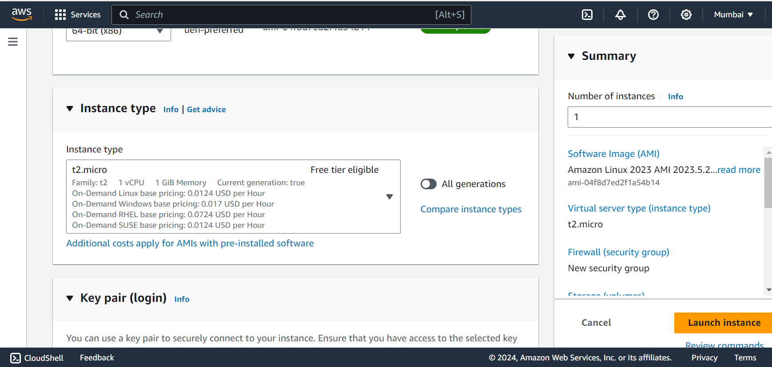

Here I have created an ec2 instance in Mumbai server zone – apsoutheast 1a with t.2 micro.

This we have to write in the advanced section for adding a web server in the ec2 instance.

#!/bin/bash

yum install httpd -y

echo "This server is running in the AWS cloud." >> /var/www/html/index.html

systemctl start httpd

systemctl enable httpd

useradd name -p redhat -c "name"

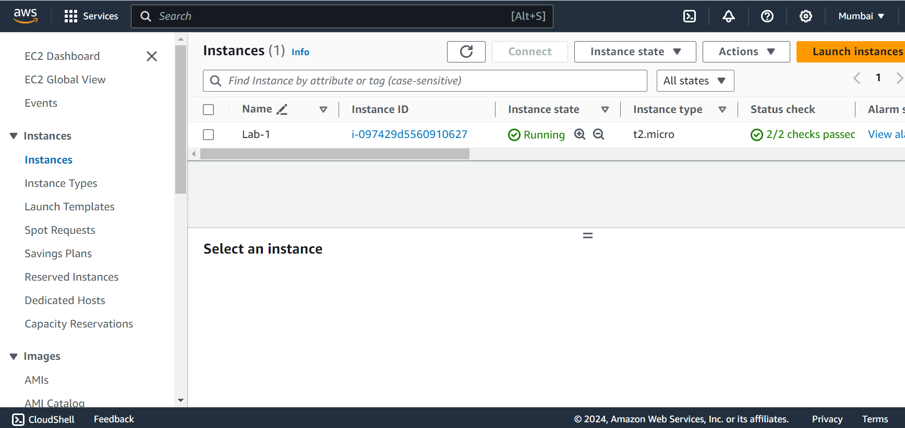

Instance is live.

Web server is live.

A 5 GB EBS volume is attached to the instance.

We can see that a 5 gb volume is attached and file system has been assigned and it has been mounted on the disk in the disk directory.

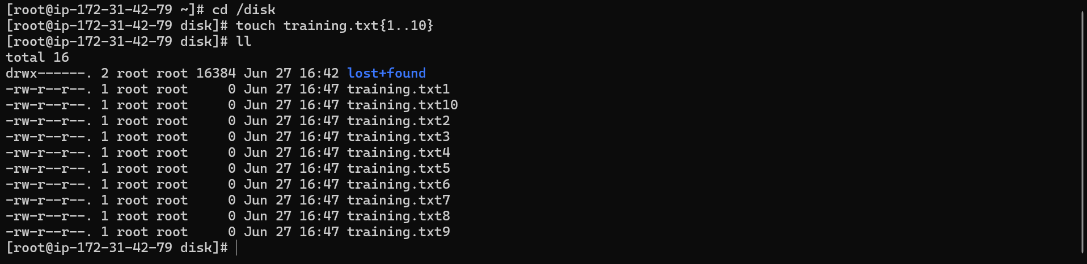

We can see that 10 files have been created in the directory named training.txt.

Commands to execute in the terminal –

lsblk

mkdir /disk

mkfs.ext4 /dev/xvdb

mount /dev/xvdb /disk/

df -h

cd /disk

touch training.txt{1..10}

ll